OOP Lab 8
Lab Tasks
Name: Murtaza Hunaid Terai
Roll No.: 24K-0782
Section: BCS-2F

Task 3:

Question 1:

Yes, a friend function can be used to overload the += operator or any operator that modifies the left-hand operand. The friend function must take the left-hand operand as a reference parameter to modify it and return a reference to the modified object for chaining.

#include <iostream>
using namespace std;

class Number {
private:
int value;
public:
Number(int v) : value(v) {}
void print() const { cout << "Value: " << value << endl; }

friend Number& operator+=(Number& lhs, const Number& rhs);
};

Number& operator+=(Number& lhs, const Number& rhs) {
lhs.value += rhs.value;
return lhs;
}

int main() {
Number obj1(5), obj2(10);
obj1 += obj2;
obj1.print();
return 0;
}

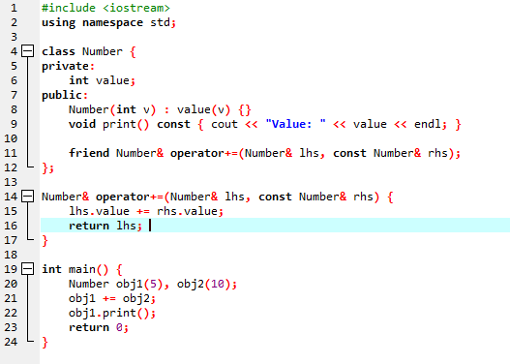

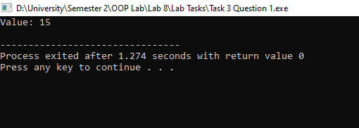

Question 2:

Yes, a friend function can handle this case. It is especially useful when the primitive type is on the right-hand side, for e.g., object + int. If the primitive is on the left, for e.g., int + object, the friend function must be defined to handle that order.

#include <iostream>
using namespace std;

class Number {
private:
int value;
public:
Number(int v) : value(v) {}
void print() const { cout << "Value: " << value << endl; }

friend Number operator+(const Number& lhs, int rhs);

friend Number operator+(int lhs, const Number& rhs);
};

Number operator+(const Number& lhs, int rhs) {
return Number(lhs.value + rhs);
}

Number operator+(int lhs, const Number& rhs) {
return Number(lhs + rhs.value);
}

int main() {
Number obj(5);
Number result1 = obj + 10;
result1.print();
Number result2 = 10 + obj;
result2.print();
return 0;
}

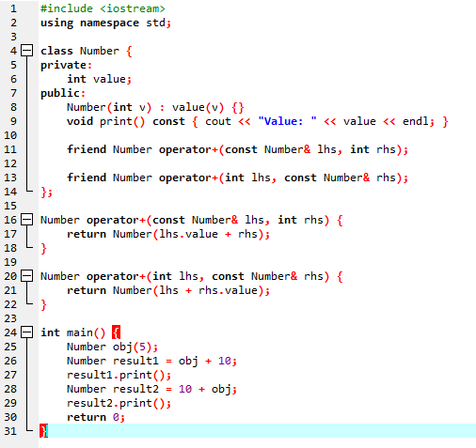

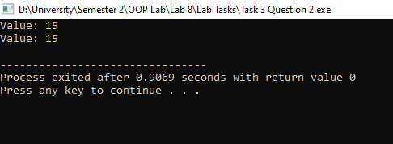

Question 3:

No, a friend function cannot access private and protected members of a class without using an object. Friend functions require an instance of the class to access its private members.

#include <iostream>
using namespace std;

class Number {
int value;
public:
Number(int v) : value(v) {}

friend void showPrivateValue(Number obj);

void display() { cout << "Value: " << value << endl; }
};

void showPrivateValue(Number obj) {
cout << "Private value: " << obj.value << endl;
}

int main() {
Number num(20);
showPrivateValue(num);
return 0;
}

